TECHNICAL PROJECT REPORT

Title of Invention / Project:

Pulse Detecting Light

Team Members / Inventors:

|  |  |  |  |  |  |
| --- | --- | --- | --- | --- | --- |
| **S. No.** | **Name** | **Department** | **Designation** | **Mobile** | **E-Mail** |
| 1. | A.GEETHA SAATVIK | CSE | STUDENT | 8179565945 | adepusaatvik@gmail.com |
| 2. | S.SURYA SNEHAVI | CSE | STUDENT | 9912282388 | sanapalasuryasnehavi@gmail.com |
| 3. | P.USHASWINI | CSE | STUDENT | 6302231689 | polemonipandu2001@gmail.com |
| 4. | Khushal Thakur | ECE | Mentor | 9646030764 | khushal.thakur@cumail.in |
| 5. | Anshul Sharma | ECE | Mentor | 9478697475 | anshulsharma.ece@cumail.in |
| 6. | Kiran Jot Singh | ECE | Mentor | 9463909689 | kiranjotsingh.ece@cumal.in |
| 7. | Divneet Singh Kapoor | ECE | Mentor | 9878422653 | divneet.ece@cumail.in |

***Section – 1 (IPR Related)***

Brief Abstract:

* The problem that our project solving is that It can sense the pulse of the human and blinks the light.
* We are using Pulse Detector and LED to know the pulse with the help of a software.
* We can connect LCD Display to know the pulse rate.

Existing state-of-the-art and Drawbacks in existing state-of-the-art

(*Brief background of the existing knowledge*)

|  |  |  |
| --- | --- | --- |
| **S. No.** | **Existing state of art** | **Drawbacks in existing state of art** |
| 1 | Blinking of light | It doesn't shows the rate of pulse |

* For our project we can’t get any Patent.

Novel/Additional modifications that you can propose to improve upon drawbacks

*(List down the features)*

* We can run this whole circuit by using Battery also.
* By connecting LCD Display also.

Advantages

(*List down the advantages, if each feature is incorporated)*

* To Sense the pulse

Block Diagram

(*Functional diagram depicting the flow of information in your system. Do not define exact components, only use generic terms. Must include modifications as well.)*

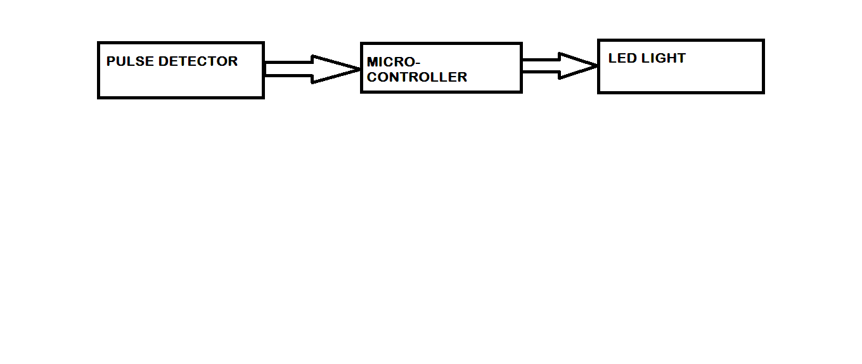

***Section – 2 (Real Project)***

Materials

Arduino Uno, Breadboard, Pulse Detector, 10k resistor, LCD, Jumper wires.

Circuit Diagram

(*Fully functional circuit diagram with exact connections. Can use Fritzing/Proteus*)

Steps of Circuit Completion

(*Bifurcate the circuit completion in steps, specify with photographs, leading to final project*)

Step 1:

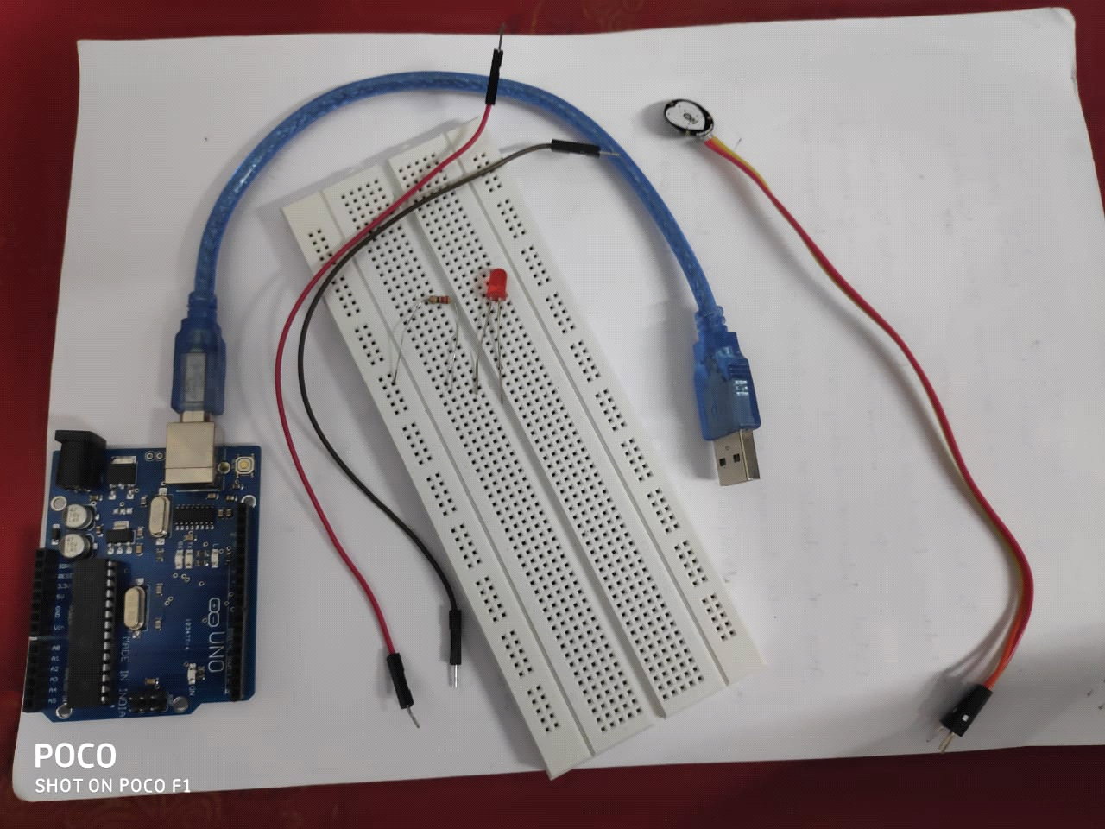

Step 2:

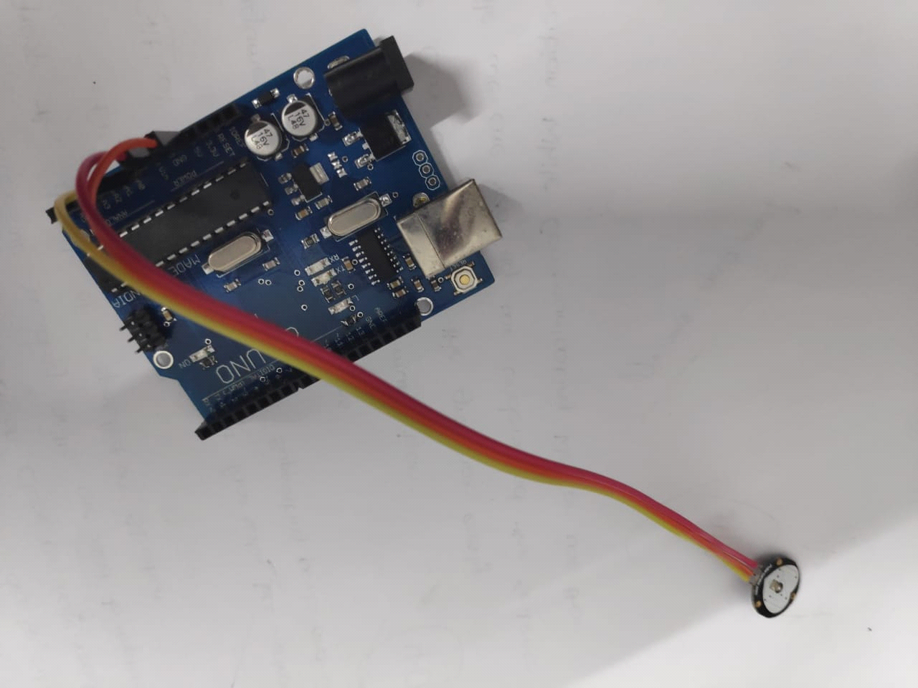

Step 3:

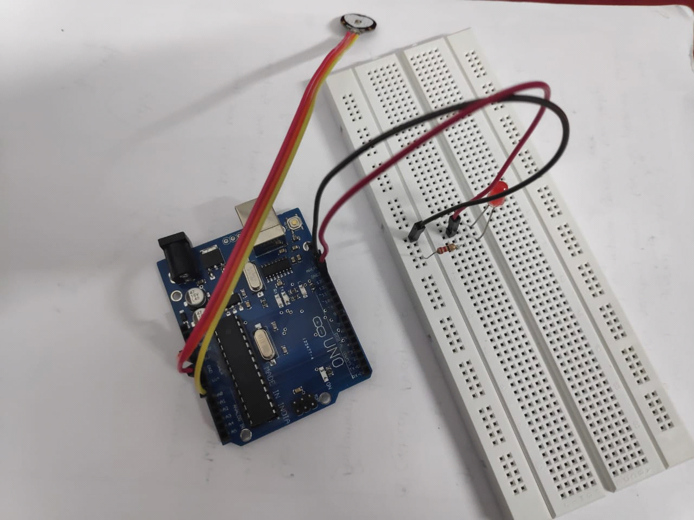

Step 4:

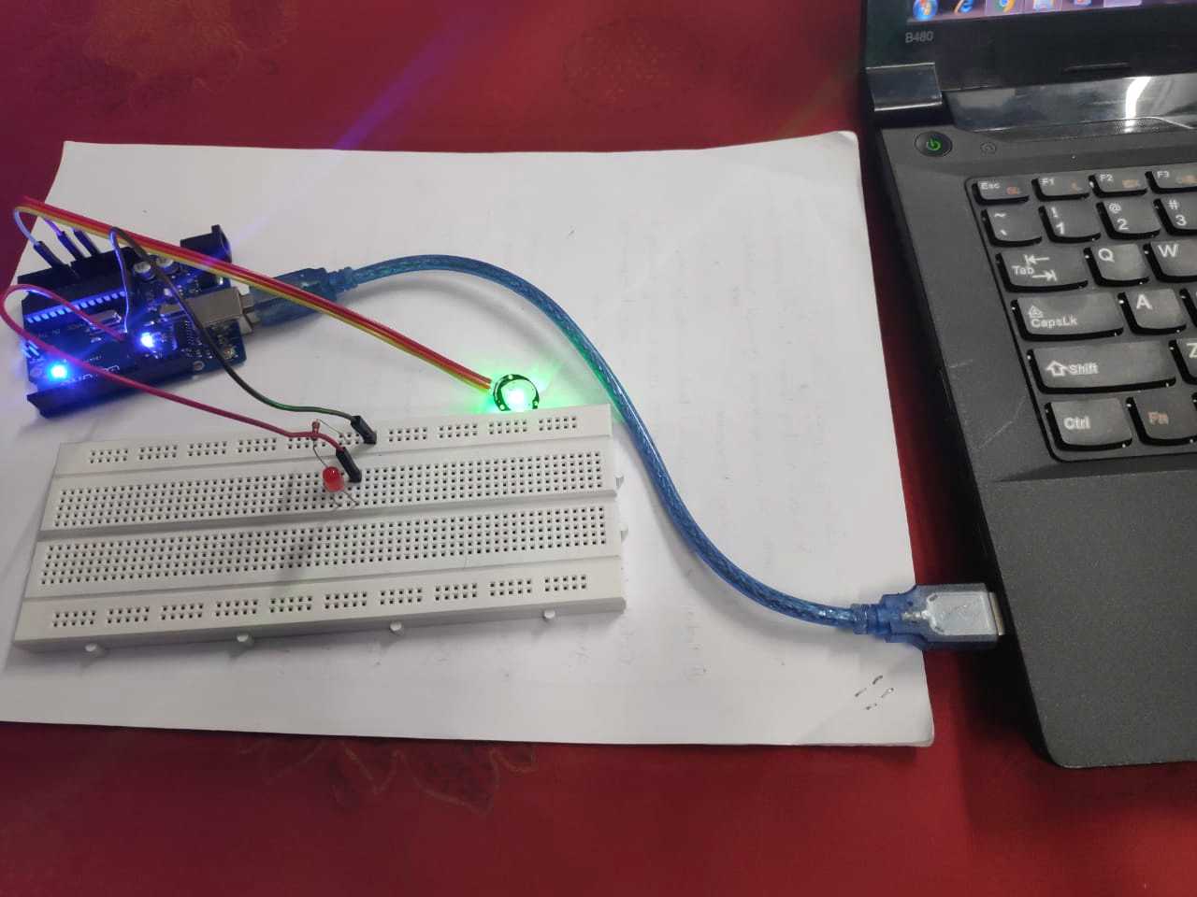

Program Code: